- PLOW BOLT-ON SEGMENT -
Customer Name:  Customer Address: | Plow Make:  Plow Model No.:  OEM Part No.:
CHECK SEGMENT TYPE & COMPLETE ALL REQUIRED DIMENSIONS
SIZE
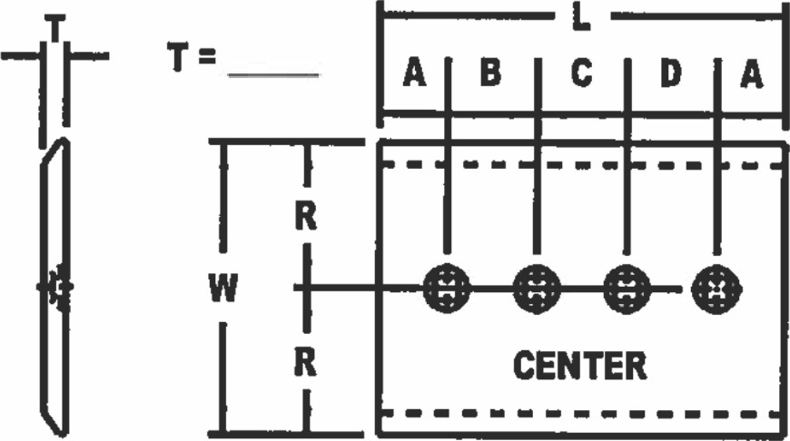
TYPE #1 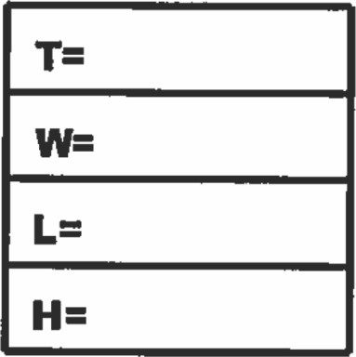

ROW
TYPE TYPE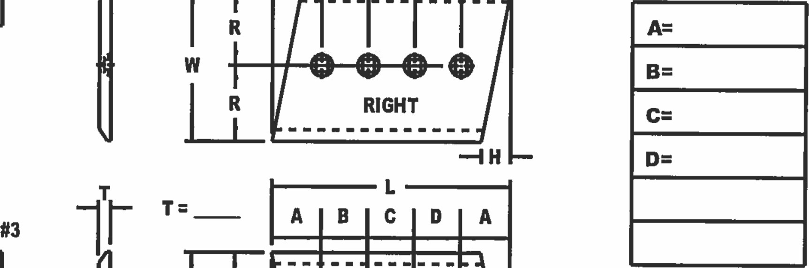

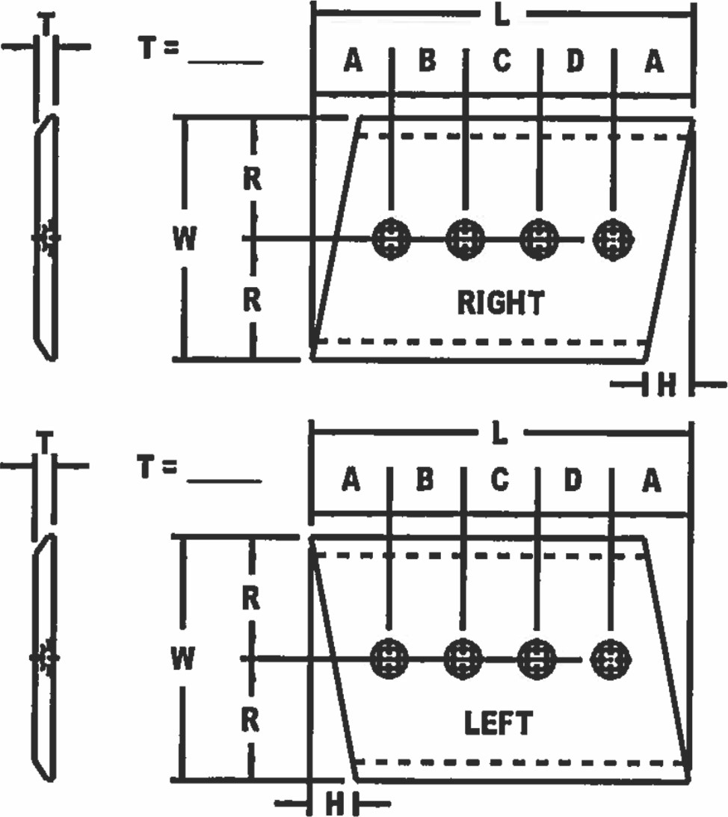
HOLE CTRS
NOTES:
til RIGHT & LEFT SEGMENTS ARE USED ONLY ON SPADE TYPE LOADER BASE EDGES
[21 SOME SEGMENTS MAY
HAVE MORE THAN 4 HOLES — ADD HOLES TO DRMNG
IF REQUIRED
DIMENSIONS IN : O INCHES O MILLIMETERS
NO. OF  HOLES = | BOLT SIZE  (CIRCLE REQUIRED) | 112" | 518" | 314 | 718" | 1-1/4"

