Cutting Edge Drawing Template Bolt On: One Row of Holes
Date:
Company:
Company Contact:
Machine Make:
Model:
BCB Contact:
 |  | Material | Profile
 |  | Heat-Treated  O carbon | Double Bevel  C] Single Bevel |  |  |  |  | 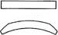  C] Square Edge  Curved
 | Hole Type |  |  |  |  | Bolt Orientation (If Applicable)
 | NO Holes C] Plow Bolt @ Round Carriage Bolt |  |  | Flat Countersink @ |  | Opposite of Bevel  Cl Same Bevel
 | Number Of Bolt Holes: |  |  | Bolt Diameter
 | Blade Dimensions
 | 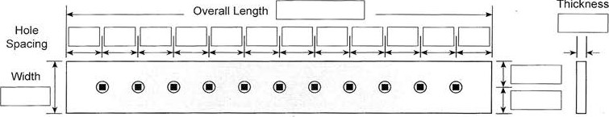
Serrated Blade Options
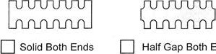  Ends |  |  |  |  | C] Solid one End |  | 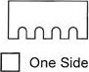 |  | 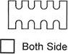
Tooth Width: Gap Width: |  |  |  |  |  |  | Tooth Length:
Additional Information.

